EXPERIMENT-39
AIM
To build a K-Means clustering model that groups e-commerce customers based on their total spending and number of items purchased, and visualize the customer segments for marketing insights.
ALGORITHM
- Import libraries (pandas, matplotlib, seaborn, sklearn).
- Load the customer transaction dataset.
- Select the features:
- Total amount spent
- Number of items purchased
- Scale the data using StandardScaler.
- Apply K-Means clustering with a chosen number of clusters (e.g., k=3).
- Fit the model and predict cluster labels.
- Add cluster labels back to the dataframe.
- Visualize the clusters using scatter plots.
- Interpret the cluster characteristics.
CODE
import pandas as pd
import matplotlib.pyplot as plt
from sklearn.cluster import KMeans
from sklearn.preprocessing import StandardScaler

# Sample dataset
data = {
'CustomerID': [101, 102, 103, 104, 105, 106],
'Total_Spending': [500, 1500, 700, 3000, 250, 1200],
'Items_Purchased': [5, 15, 8, 25, 3, 12]
}

df = pd.DataFrame(data)

# Select features
X = df[['Total_Spending', 'Items_Purchased']]

# Scale features
scaler = StandardScaler()
X_scaled = scaler.fit_transform(X)

# Build KMeans model
kmeans = KMeans(n_clusters=3, random_state=42)
df['Cluster'] = kmeans.fit_predict(X_scaled)

print("Clustered Data:")
print(df)

# Visualization
plt.scatter(df['Total_Spending'], df['Items_Purchased'], c=df['Cluster'])
plt.xlabel("Total Spending")
plt.ylabel("Items Purchased")
plt.title("Customer Segmentation Using K-Means")
plt.show()
INPUT:
Clustered Data:
 | CustomerID | Total_Spending | Items_Purchased | Cluster
0 | 101 | 500 | 5 | 0
1 | 102 | 1500 | 15 | 2
2 | 103 | 700 | 8 | 0
3 | 104 | 3000 | 25 | 1
4 | 105 | 250 | 3 | 0
5 | 106 | 1200 | 12 | 2

OUTPUT:

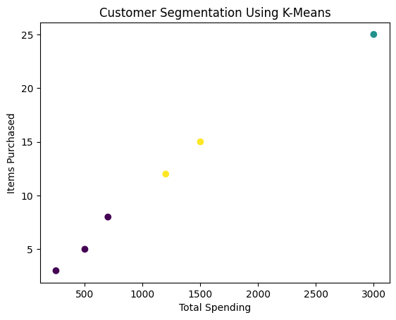
RESULT
The K-Means clustering model successfully grouped customers into three distinct segments based on their spending and purchase behavior. The scatter plot clearly shows the separation of high spenders, moderate customers, and low spenders, helping the marketing team design targeted campaigns.

